Organizational Justice
WEBINAR
Join us as a favorite speaker, Susanne Meninger, MS, RN, CPPS, CIC, shares the latest information on organizational justice and performance improvement!
Objectives:
Participants will be able to describe types of organizational justice
Participants will be able to how types of organizational justice may foster or impede performance improvement

Tuesday

May
21st
3pm EDT

About the Speaker:
Susanne has broad competency in Human Factors, Information technology, Teamwork, Patient Safety, Evidence-Based Management, Behavior Change and Creative Writing. She currently works in Infection Prevention and Quality & Patient Safety. Susanne holds a BS in Nursing, a MS in Industrial Organizational Psychology, a graduate certificate in Patient Safety, Error Science and Full Disclosure from the University of Illinois at Chicago, and certifications in Infection Prevention and Patient Safety.

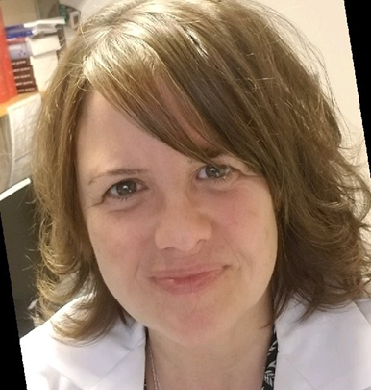

FREE event for members of NEAHQ
FREE event for members of MAHQ, OrAHQ, NCAHQ, FAHQ, AzAHQ, GAHQ, OAHQ, TGCAHQ by selecting your association's ticket type and using discount code provided by your association
$15 for Non-Members
Click here for more details and to register

